1. How are angular frequency and amplitude affected by time etc?
2. Reading in V-I meters immediately and after long time.

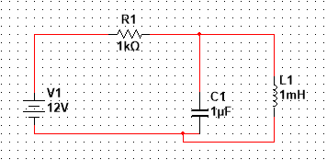

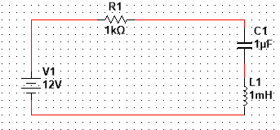

1. LR maximum energy, time to reach fraction of maximum, current at time
2. LC circuit charge, max energy in capacitor, time etc.